**Project Identification**

|  |  |
| --- | --- |
| **Project:** | Chatbot Web App |
| **Prepared By:** | Jesse Hughes |
| **Document Version:** | 1.0 |
| **Published Date:** | 10/08/2021 |

**Contributors**

The following individuals contributed to this document.

| **Name** | **Title** |
| --- | --- |
| Jesse Hughes | *Project Member* |

**Distribution**

This document is distributed to all the following people.

| **Name** | **Title** |
| --- | --- |
| Jerish Bradly | Project Leader |
| Naveen Jose | Project Member and Moral Captain |
| Sanjay Kannan | Project Member |

**Referenced Documents**

This document refers to the following materials

|  |  |  |  |  |
| --- | --- | --- | --- | --- |
| **Version number** | **Title** | **Author** | **Date** | **Source / Location** |
|  |  |  |  |  |
|  |  |  |  |  |
|  |  |  |  |  |

**Revision History**

|  |  |  |  |
| --- | --- | --- | --- |
| **Version Number** | **Revision Date** | **Summary of Changes** | **Modified by** |
| 1.0 | *10/08/2021* | High Level Requirements document created | Jesse Hughes |
|  |  |  |  |
|  |  |  |  |

[Note: It is recommended that drafts be numbered 0.1 to 0.9, and that the first approved version be numbered 1.0. Thereafter, new version numbers will depend upon changes: 1.01, 1.1, etc for minor updates, 2.0, 3.0 etc for major changes.]

TABLE OF CONTENTS

1. Business Context Diagram 3

2. REquirements Scope Statements 4

3. High Level Business Requirements (HLR) Traceability 4

4. High Level Business Requirements Sign-Off 5

1. Business Context Diagram

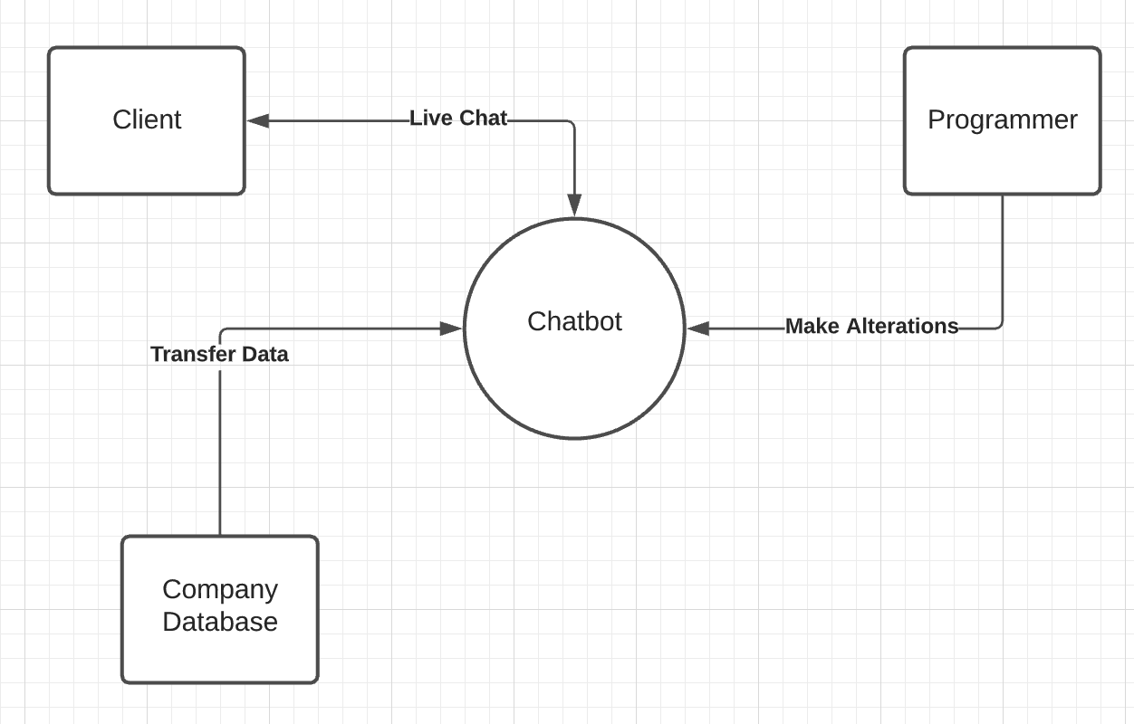

|  |  |
| --- | --- |
| **Requirement Scope Area** | **Description** |
| Website Chatbot | Interactive chatbot to provide information and assistance to clients. |

|  |  |
| --- | --- |
| **External Entity** | **Description** |
| Client | Client who can talk with chatbot |
| Company Database | Database of information for chatbot |
| Programmer | Programmer makes modifications to chatbot |

| **Information Flows** | **Description** |
| --- | --- |
| Live Chat | The conversation between client and chatbot |
| Transfer Data | Any information the database sends to the chatbot |
| Make Alterations | Any changes programmer makes to the chatbot |

1. Requirements Scope Statements

|  |  |  |
| --- | --- | --- |
| **HLR#** | **Description** | **Priority**  **(H, M, L)** |
|  | Client must be able to understand chatbot | H |
|  | Client must be able to find information | H |
|  | Company must be able to pass data to chatbot | H |

1. High Level Business Requirements Sign-Off

The undersigned acknowledge their agreement with the contents of Version 1.0 of the High-Level Requirements document for Chatbot Web App.

Following approval of this document, requirements changes will be governed by the project’s change management process, including impact analysis and appropriate reviews and approvals, under the general control of the Project Plan and according to company policy. Approved Change Request Documents, if present, will be attached to this Requirements Document as updates.

|  |  |  |
| --- | --- | --- |
| **Name** | **Project Role and**  **Functional Area** | **Date Signed** |
| Jerish Bradly | Project Leader | 10/08/2021 |
| Jesse Hughes | Project Member | 10/08/2021 |
| Naveen Jose | Project Member and Moral Captain | 10/08/2021 |
| Sanjay Kannan | Project Member | 10/08/2021 |

* Note: physical signatures are not required. Email approvals are acceptable and should be appended to project documents.